## Paper Bag Frog Puppet

*Catalina Council*

**Materials:**

Paper lunch bag

Printer and paper

Green paint (or construction paper)

Scissors

Glue and/or tape

Something to color with



**Familiarize Yourself With The Bag:**

1. Look at your paper bag. It should be closed and flat like a piece of paper. Just like when they are brand new. On one side, it's all smooth. This will be the BACK of your puppet. It's important that all the kids get the back and front straight at the beginning!
2. On the other side there's a flippy tab (which is typically the bottom of the bag when you're carrying your lunch around...) This flippy tab will be the puppet's HEAD.
3. Lift the flippy tab up a bit. Underneath of the FLAP will be the puppet's mouth. When the child put's his hand in the bag, he'll be able to make the puppet talk.
4. Look at the rest of the front of the bag. (The 3/4 or so of the bag below the part with the flippy tab) This will be the BODY.
5. Look at the sides of the bag. There should be a SIDE FLAP of paper. We'll be slipping the arms into this flap.

**Putting The Puppet Together:**

1. Paint the front of your paper bag green.
2. Set aside to dry. OR As an alternative to painting, trace the body of the paper bag and the head of the paper bag onto green construction paper. Cut it out and glue it to the bag.
3. Print the template pieces. Template pieces are at the end of Baloo's Bugle.
4. Color the largest circles and arms green (or whatever color your frog is going to be.
5. Color the long rectangle (ish) piece red (FRONT AND BACK!)
6. Color the smallest circles black
7. Cut out the pieces.
8. Put one of the green circles in front of you. Glue the medium sized (white) circle onto it. Glue the small (black) circle onto that. Repeat with the other set of circles. Now you have two eyes!
9. Take the red long rectangle and wrap it around a pencil to give it a curl. This will be the tongue.
10. By this time, your bag should be dry. Glue the eyes onto the top of the HEAD. You can see from the photo above that the eyes stick up over the top of the head.
11. Lift the FLAP and glue the tongue underneath.
12. Glue the arms into the SIDE FLAP. When you do this, glue or tape them onto the top of the flap not the bottom. That way when you're using the puppet, it's arms will reach forward in a hugging motion instead of bending way backwards.
13. OPTIONAL: You can personalize your basic frog puppet in a lot of ways
14. Put a construction paper or gift wrap bowtie on the frog.
15. Draw marker or paint speckles/warts/dots on your frog's body.
16. Take a small black pom pom. Attach some wax paper wings and small googly eyes to make a fly. Glue it to the frog's tongue.
17. Glue something into the frog's hand.
18. Put a small piece of Velcro on the frog's hand. Put Velcro on numerous objects. That allows you to change the frog's "props" during a puppet show. *If you chose to do this, you'll want to back the frog's arm with a thin piece of cardboard (old cereal box) so it doesn't flop around.*
19. Glue some construction paper froggy feet to the bottom of the bag.

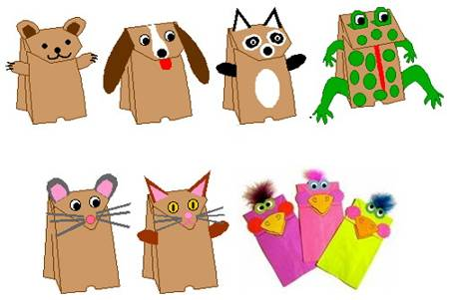

For more Paper Bag Puppet Instructions - Go to -   
[**www.enchantedlearning.com/crafts/puppets/paperbag/**](http://www.enchantedlearning.com/crafts/puppets/paperbag/)